


A PROJECT REPORT
on
Sports Quiz Generator
Submitted in partial fulfillment of requirements for the award of the course of

CGB1121–PYTHON PROGRAMMING

Under the guidance of

Ms. M Indhu M.E,
Assistant Professor/ECE

Submitted By

Shahin Ashika K (8115U23EC097)

DEPARTMENT OF ELECTRONICS AND COMMUNICATION ENGINEERING

K.RAMAKRISHNANCOLLEGEOFENGINEERING
(An Autonomous Institution , affiliated to Anna University Chennai and Approved by AICTE, New Delhi
SAMAYAPURAM–621112



K.RAMAKRISHNAN COLLEGE OF ENGINEERING
(An Autonomous Institution , affiliated to Anna University Chennai and Approved by AICTE, New Delhi)

SAMAYAPURAM–621112
JUNE 2024

BONAFIDE CERTIFICATE
Certified that this project report titled “SPORTS QUIZ GENERATOR” is the bonafide work of SHAHIN ASHIKA K (8115U23EC097),who carried out the project work under my supervision. Certified further, that to the best of my knowledge the work reported here it does not form part of any other project report or dissertation on the basis of which a degree or award was conferred on an earlier occasion on this or any other candidate.
SIGNATURE  Dr.M. MAHESWARI Ph.D.,  HEAD OF THE DEPARTMENT  PROFESSOR,  Department of Computer Science and Engineering,  K.Ramakrishnan College of Engineering (Autonomous)  Samayapuram–621112 | SIGNATURE  Ms. M. Indhu M.E,  SUPERVISOR  ASSISTANT PROFESSOR,  Department of Computer Science and Engineering,,  K.Ramakrishnan College of Engineering  (Autonomous)  Samayapuram–621112

Submitted for the End Semester Examination held on ……………….

INTERNAL EXAMINER EXTERNAL EXAMINER

DECLARATION

I jointly declare that the project report on “SPORTS QUIZ GENERATOR” is the result of original work done by us and best of our knowledge, similar work has not been submitted to “ANNA UNIVERSITY CHENNAI” for the requirement of Degree of BACHELOR OF ENGINEERING. This project report is submitted on the partial fulfillment of the requirement of the award of degree of BACHELOR OF ENGINEERING.

Signature
SHAHIN ASHIKA.K

Place: Samayapuram
Date:

ACKNOWLEDGEMENT

It is with great pride that we express our gratitude and indebtedness to our institution, “K. Ramakrishnan College of Engineering (Autonomous)”, for providing us with the opportunity to do this project.
We extend our sincere acknowledgment and appreciation to the esteemed and honorable Chairman, Dr. K. RAMAKRISHNAN, B.E., for having provided the facilities during the course of our study in college.
We would like to express our sincere thanks to our beloved Executive Director, Dr. S. KUPPUSAMY, MBA, Ph.D., for forwarding our project and offering an adequate duration to complete it.
We would like to thank Dr. D. SRINIVASAN, B.E, M.E.,Ph.D.,
Principal,who gave the opportunity to frame the project to full satisfaction.

We thank Dr.M. MAHESWARI Ph.D., Head of the Department of COMPUTER SCIENCE AND ENGINEERING, for providing her encouragement in pursuing this project.
We wish to convey our profound and heartfelt gratitude to our esteemed project guide Ms. M. INDHU M.E., Department of COMPUTER SCIENCE AND ENGINEERING, for her incalculable suggestions, creativity , assistance and patience, which motivated us to carry out this project.
We render our sincere thanks to the Course Coordinator and other staff members for providing valuable information during the course.
We wish to express our special thanks to the officials and Lab Technicians of our departments who rendered their help during the period of the work progress



VISION
To achieve a prominent position among the top technical institutions
MISSION
- To bestow standard technical education par excellence through state of the art infrastructure, competent faculty and high ethical standards.
- To nurture research and entrepreneurial skills among students in cutting edge technologies.
- To provide education for developing high-quality professionals to transform the society.

DEPARTMENT VISION AND MISSION

VISION
To create eminent professionals of Computer Science and Engineering by imparting quality education.
MISSION
- To provide technical exposure in the field of Computer Science and Engineering through state of the art infrastructure and ethical standards.
- To engage the students in research and development activities in the field of Computer Science and Engineering.
- To empower the learners to involve in industrial and multi-disciplinary projects for addressing the societal needs.
PROGRAMME EDUCATIONAL OBJECTIVES (PEOs)
PEO1: Analyse, design and create innovative products for addressing social needs.
PEO2: Equip themselves for employability, higher studies and research.
PEO3: Nurture the leadership qualities and entrepreneurial skills for their successful career.
PROGRAMOUTCOMES(POs)
Engineering students will be able to:
- Engineering knowledge: Apply the knowledge of mathematics, science, engineering fundamentals ,and an engineering specialization to the solution of complex engineering problems.

- Problem analysis: Identify, formulate, review research literature, and analyze complex engineering problems reaching substantiated conclusions using first principles of mathematics, natural sciences, and engineering sciences.
- Design/development of solutions: Design solutions for complex engineering problems and design system components or processes that meet the specified needs with appropriate consideration for the public health and safety, and the cultural, societal, and environmental considerations.
- Conduct investigations of complex problems: Use research-based knowledge and research methods including design of experiments, analysis and interpretation of data ,and synthesis of the information to provide valid conclusions.
- Modern tool usage: Create, select, and apply appropriate techniques, resources, and modern engineeringandITtoolsincludingpredictionandmodelingtocomplexengineeringactivitieswith an understanding of the limitations.
- The engineer and society: Apply reasoning informed by the contextual knowledge to assess societal, health, safety ,legal and cultural issues and the consequent responsibilities relevant to the professional engineering practice.
- Environment and sustainability: Understand the impact of the professional engineering solutions in society a land environmental contexts ,and demonstrate the knowledge of, and need for sustainable development.
- Ethics: Apply ethical principles and commit to professional ethics and responsibilities and norms of the engineering practice.
- Individual and team work: Function effectively as an individual, and as a member or leader in diverse teams, and in multidisciplinary settings.

- Communication: Communicate effectively on complex engineering activities with the engineering community and with society at large, such as, being able to comprehend and write effective reports and design documentation, make effective presentations, and give and receive clear instructions.

- Project management and finance: Demonstrate knowledge and understanding of the engineering and management principles and apply these to one’s own work, as a member and leader in a team, to manage projects and in multidisciplinary environments.
- Life-long learning: Recognize the need for, and have the preparation and ability to engage in independent and life-long learning in the broadest context of technological change.
PROGRAM SPECIFIC OUTCOMES(PSOs)

PSO1: Apply the basic and advanced knowledge in developing software, hardware and firm ware solutions addressing real life problems.
PSO2: Design, develop, test and implement product-based solutions for their career enhancement

ABSTRACT

The Sports Quiz Generator is an innovative tool designed to create engaging and educational quizzes focused on various sports disciplines. Leveraging a comprehensive database of sports trivia, historical data, and current events, the generator can produce customized quizzes that cater to different difficulty levels and sports interests. Users can specify parameters such as the number of questions, specific sports categories (e.g., football, basketball, tennis), and difficulty settings (e.g., beginner, intermediate, expert).Additionally, the Sports Quiz Generator includes a scoring and feedback system to enhance the learning experience. After completing a quiz, users receive immediate feedback on their performance, including detailed explanations of the correct answers. This feature not only helps users gauge their knowledge but also deepens their understanding of various sports topics. Whether used for personal enjoyment, classroom activities, or competitive events, the Sports Quiz Generator offers a dynamic and interactive way to celebrate and explore the world of sports.

CHAPTERNO | TITLE | PAGE NO
1 | INTRODUCTION  - Introduction  - Objectives  - Project Summarization | 1  5  5
2 | PROJECTMETHODOLOGY  2.1 Methodology  2.2 Tools and Technologies Used | 7  9
3 | PYTHON PREFERENCE  - Why Python Prefers IMDb()  - Features in python | 12  12
4 | DATASTRUCTURES USED  - Array or Lists  - Dictionaries  - Trees  - Graphs  - Hash Tables  - Trie  - Linked List | 14  14  14  14  14  14  14
5 | MODULES  - Web development frameworks  - Database Management  - Web scraping and API integration  - User interface and templates  - Data analysis and manipulation  - Natural language processing(NPL)  - Authentication and security  - Testing | 16  16  16  16  16  17  17  17  17
6 | ERROR MANAGEMENT  6.1 Exception handling  6.2 Logging  6.3 Custom exceptions  6.4 Input validation  6.5 Error messages and user feedback  6.6 Testing and monitoring | 18  18  18  18  18  18  18

7 | RESULT & DISCUSSION  7.1 Result  7.2 Output  7.3 Discussion | 19  19  21  21
8 | CONCLUSION & FUTURE SCOPE  8.1 Conclusion  8.2 Future Scope | 22  22  22
9 | REFERENCES  APPENDIX – A | 24  26

CHAPTER1 – INTRODUCTION
1.1 Introduction:
- Diverse Sports Coverage:
    - Questions from various sports including soccer, basketball, baseball, tennis, cricket, and more.
    - Categories ranging from player stats, historic matches, to sports rules and trivia.
- Customizable Difficulty Levels:
- Choose between easy, medium, and hard questions to match
- your knowledge level.
- Perfect for both casual fans and sports experts.
- Multiple Question Formats:
    - Multiple-choice questions.
    - True or false statements.
    - Fill-in-the-blank questions.
    - Picture-based questions for identifying players, logos, and moments.
- Instant Feedback:
- Get immediate feedback on your answers.
- Detailed explanations for each question to help you learn more about the sport.
- Timer Settings:
- Set timers for each question to increase the challenge.
- Optional timed quizzes for a competitive edge.
- Leader board and Scoring:
- Track your scores and compete with friends.
- See how you rank on the leader board among other sports fans.

5.Regular Updates:
- Constantly updated with new questions to keep the quizzes fresh and exciting.
- Special quizzes for major sports events and seasons.

1.1.1 Purpose and Importance:
Purpose:
1.Entertainment and Fun:
- Provide an engaging and entertaining way for sports fans to test their knowledge and enjoy their favorite pastime.
- Create a platform for friendly competition among friends, family, and other sports enthusiasts.
2.Educational Tool:
- Serve as an educational resource to help users learn more about various sports, their histories, rules, and key figures.
- Offer detailed explanations for answers to help users deepen their understanding of sports trivia and facts.

3.Skill Development:
- Enhance memory and recall abilities through the process of answering quiz questions.
- Improve critical thinking and analytical skills by challenging users with a variety of question formats and difficulty levels.
4.Community Building:
- Foster a sense of community among sports fans by providing a common platform for interaction and competition.
- Encourage social interaction and bonding through shared interests in sports trivia and quizzes.
5.Promotional Tool:
- Act as a promotional tool for sports teams, events, or leagues by generating interest and engagement among fans.
- Provide a fun and interactive way for brands and sponsors to connect with their audience through customized quiz content.
Importance:
1.Engagement:
- Keeps sports fans engaged during off-seasons or between major events, maintaining their interest in their favorite sports.
- Offers a fun distraction and entertainment option for individuals during their leisure time.
2.Knowledge Enhancement:
- Encourages continuous learning about sports, including lesser-known facts and historical events.
- Helps fans stay updated with current sports news and player statistics.
3.Motivation and Competition:
- Fuels competitive spirit among users, motivating them to improve their scores and knowledge.
- Provides an avenue for healthy competition and the pursuit of personal achievement.
4.Interactive Learning:
- Makes learning about sports interactive and enjoyable, appealing to a wide range of age groups.
- Utilizes various question formats and multimedia elements to cater to different learning styles.
5.Brand Loyalty:
- Enhances fan loyalty by providing a platform that connects them more deeply with their favorite sports.
- Creates opportunities for sports organizations and brands to engage with their audience in a meaningful way.
6.Market Research and Insights:
- Collects data on user preferences, popular sports topics, and quiz performance, providing valuable insights
- for sports organizations and marketers.
- Helps identify trends and interests among different demographics, aiding in targeted marketing strategies.

1.2 Objective
The primary objective of the Sports Quiz Generator is to create a versatile and user-friendly platform that enables individuals and groups to generate customized sports quizzes. This tool aims to:
1.Enhance Sports Knowledge:
Provide an engaging and educational medium for users to expand their understanding of various sports, including history, rules, and key figures.
2.Promote Engagement:
Foster an interactive environment that encourages participation and interest in sports through fun and challenging quizzes.
3.Support Customization:
Allow users to tailor quizzes to their specific preferences, including the selection of sports categories, difficulty levels, and question types.
4.Offer Current and Relevant Content:
Maintain an up-to-date question database reflecting the latest sports news and events to ensure quizzes remain relevant and informative.
5.Facilitate Learning and Feedback:
Provide immediate scoring and detailed explanations to help users learn from their quiz-taking experience and improve their sports knowledge.
By achieving these objectives, the Sports Quiz Generator aims to be a valuable resource for sports enthusiasts, educators, and event organizers, enhancing their engagement and enjoyment of sports trivia.

  - Project Summarization:
The Sports Quiz Generator project aims to develop an innovative, user-friendly platform for creating and taking customized sports quizzes. Designed to cater to sports enthusiasts, educators, and event organizers, the tool allows users to generate quizzes based on a comprehensive and regularly updated database of sports trivia, historical data, and current events.

Key components of the project include:
User Interface:
An intuitive interface that enables users to easily create quizzes by selecting sports categories (e.g., football, basketball, tennis), question types (multiple choice, true/false, fill-in-the-blank), and difficulty levels (beginner, intermediate, expert).
Customization Options:
Features that allow users to specify the number of questions and tailor quizzes to their interests, making the quizzes suitable for various contexts, from casual play to educational purposes.
Question Database:
A robust and dynamic database that is regularly updated to include the latest sports news and events, ensuring the quizzes are current and engaging.
Scoring and Feedback:
A system that provides immediate feedback on quiz performance, including detailed explanations of correct answers to facilitate learning and knowledge retention.

CHAPTER 2

PROJECT METHODOLOGY

2.1 Methodology:
The development of the Sports Quiz Generator involves several key phases, each focusing on different aspects of the project to ensure a comprehensive and functional tool. The methodology includes:
1.Requirement Analysis:
- Stakeholder Consultation: Engaging with potential users (sports enthusiasts, educators, event organizers) to gather requirements and preferences.
- Defining Features: Outlining essential features such as quiz customization, question types, difficulty levels, and feedback mechanisms.
2.Design:
- System Architecture: Designing the overall architecture, including database design, user interface, and backend logic.
- User Interface Design: Creating wireframes and prototypes for a user-friendly and intuitive interface.
3.Development:
- Database Development: Building a comprehensive and scalable database to store sports trivia, historical data, and current events.
- Backend Development: Implementing the logic for quiz generation, including algorithms for selecting questions based on user preferences and ensuring variety and balance.
- Frontend Development: Coding the user interface, ensuring it is responsive and easy to navigate.

3.Integration and Testing:
- Unit Testing: Testing individual components and features to ensure they work as intended.
- Integration Testing: Ensuring all components work together seamlessly.
- User Testing: Conducting beta testing with real users to gather feedback and identify areas for improvement.
- Performance Testing: Ensuring the system can handle multiple users and large datasets efficiently.
4.Deployment:
- Server Setup: Configuring servers and deploying the application to a live environment.
- Database Population: Importing the initial set of sports trivia and ensuring the database is up-to-date.
5.Maintenance and Updates:
- Regular Updates: Continuously updating the database with new sports data and trivia.
- Feature Enhancements: Adding new features and improvements based on user feedback and technological advancements.
- Bug Fixes: Monitoring the system for any issues and addressing them promptly.
6.Documentation and Training:
- User Guides: Providing comprehensive documentation and tutorials to help users get the most out of the tool.
- Support: Offering customer support for troubleshooting and inquiries.

Tools and Technologies Used:
The development of the Sports Quiz Generator leverages a combination of modern tools and technologies to ensure a robust, scalable, and user-friendly application. The key tools and technologies include:
1.Programming Languages:
- JavaScript: For client-side scripting to create interactive and dynamic user interfaces.
- Python: For backend development, handling data processing, and implementing quiz generation logic.
2.Web Development Frameworks and Libraries:
- React: For building the frontend user interface, providing a responsive and dynamic experience.
- Node.js: For server-side development, enabling efficient handling of requests and real-time data processing.
- Express.js: As a web application framework for Node.js, used to build the backend API.
3.Database Management:
- MongoDB: A NoSQL database for storing sports trivia, user data, and quiz results, offering flexibility and scalability.
- PostgreSQL: An optional relational database for handling structured data if required.
4.APIs and Data Sources:
- Sports Data APIs: Integrating third-party sports data APIs to keep the question database up-to-date with the latest sports events and statistics.
- Custom APIs: Developing APIs to manage data flow between the frontend and backend systems.
5.Version Control and Collaboration:
- Git: For version control, allowing for efficient tracking of changes and collaboration among developers.
- GitHub: As a repository hosting service for project management and collaboration.
6.Development and Deployment Tools:
- Docker: For containerizing the application, ensuring consistency across different environments and simplifying deployment.
- Kubernetes: For orchestrating Docker containers in a production environment, ensuring scalability and high availability.
- CI/CD Tools: Using tools like Jenkins or GitHub Actions to automate testing, integration, and deployment processes.
7.Testing Tools:
- Jest: For unit and integration testing of JavaScript code.
- Selenium: For automated end-to-end testing of the user interface.
- Postman: For API testing and ensuring the backend services function correctly.
8.User Interface and Experience Design:
- Figma: For designing user interfaces and creating interactive prototypes.
- Adobe XD: As an alternative tool for UI/UX design and prototyping.
9.Hosting and Cloud Services:
- Amazon Web Services (AWS): For cloud hosting, storage, and computing resources.
- Heroku: As an alternative for simple and quick deployment of web applications.
10.Monitoring and Analytics:
- Google Analytics: For tracking user interaction and gaining insights into user behavior.
- Prometheus and Grafana: For monitoring application performance and visualizing metrics.

CHAPTER 3
PYTHON PREFERENCE
Why Python prefers IMDb
Python is preferred for integrating IMDb-like features into the Sports Quiz Generator due to its versatility in handling data, web scraping, and database management. With libraries like Pandas and NumPy for data analysis and manipulation, Python can efficiently manage the extensive trivia database required for the quiz generator. Its web scraping capabilities, facilitated by tools like BeautifulSoup and Scrapy, enable the collection of sports data from various sources, similar to IMDb's data aggregation process. Python's frameworks such as Django and Flask support rapid web development, crucial for building the backend of a dynamic quiz platform. Additionally, Python's natural language processing libraries like NLTK and SpaCy can aid in generating meaningful quiz questions and processing user inputs. Leveraging Python's extensive ecosystem and community support, developers can create a feature-rich Sports Quiz Generator that offers a comprehensive and engaging quiz experience inspired by IMDb's structured data approach.

3.2 Features in Python
In Python, developing a Sports Quiz Generator involves implementing various features to create an engaging and educational platform. Some key features include:
- Customizable Quizzes: Allow users to customize quizzes based on their preferences, including the number of questions, difficulty levels, and specific sports categories.
- Extensive Question Database: Implement a comprehensive database of sports trivia, historical data, and current events across multiple sports disciplines.
- Multiple Question Types: Support different question formats such as multiple choice, true/false, and fill-in-the-blank to keep the quizzes diverse and engaging.
- Dynamic Quiz Generation: Develop algorithms to dynamically generate quizzes based on user preferences, ensuring a unique experience for each quiz session.
- Real-time Data Updates: Integrate with sports data APIs to fetch and update quiz content in real-time, reflecting the latest sports news and events.
- Scoring and Feedback System: Provide immediate feedback on quiz performance, including scoring and detailed explanations of correct answers to facilitate learning.
- User Authentication and Profiles: Implement user authentication to track quiz progress and performance over time, allowing users to view their quiz history and achievements.
- Responsive User Interface: Design a responsive and user-friendly interface using Python frameworks like Django or Flask, ensuring compatibility across devices and browsers.
- Social Sharing and Leaderboards: Enable users to share quiz results on social media platforms and compete with friends through leaderboards, enhancing engagement and competitiveness.
- Educational Resources: Include additional educational resources such as sports articles, videos, and tutorials to complement the quiz experience and further enrich users' sports knowledge.

CHAPTER-4
PYTHON DATA STRUCTURE

In a Sports Quiz Generator, various data structures can be utilized to manage and organize the quiz-related data efficiently. Here are some commonly used data structures in such applications:
4.1 Arrays or Lists: Arrays or lists are versatile data structures used to store collections of quiz questions, answers, and options. They can be organized by categories (e.g., sports disciplines) or difficulty levels, allowing for easy retrieval and manipulation of quiz content.

4.2 Dictionaries: Dictionaries are useful for storing key-value pairs, such as question-answer pairs or question-options pairs. They enable fast lookup of quiz data based on keys (e.g., question IDs) and support organizing quiz content hierarchically (e.g., by sports category).
4.3 Trees: Trees can be employed to represent hierarchical structures in the quiz database, such as organizing questions into categories and subcategories. This allows for efficient navigation and categorization of quiz content.
4.4 Graphs: Graphs can model relationships between quiz elements, such as dependencies between questions (e.g., prerequisites) or connections between related topics. They facilitate complex data relationships and can optimize quiz generation algorithms.
4.5 Hash Tables: Hash tables provide fast access to quiz data through key-value mapping, making them suitable for storing and retrieving large volumes of quiz content efficiently.
4.6 Trie: Tries can be used for efficient storage and retrieval of quiz-related strings, such as keywords, tags, or search terms. They excel in scenarios where fast prefix-based searches are required, such as autocomplete features in quiz search functionalities.
4.7 Linked Lists: Linked lists can be utilized to represent sequences of quiz elements, such as quiz questions or answers. They offer flexibility in dynamic memory allocation and are suitable for scenarios where frequent insertion or deletion operations are performed.
The choice of data structure(s) depends on factors such as the complexity of the quiz content, the frequency of data operations (e.g., retrieval, insertion, deletion), and the performance requirements of the application. A combination of these data structures may be employed to optimize the efficiency and effectiveness of the Sports Quiz Generator.

CHAPTER- 5

MODULES
In a Sports Quiz Generator implemented in Python, various modules can be utilized to facilitate different aspects of the application, ranging from web development to data management and user interaction. Here are some essential modules commonly used in such projects:
5.1 Web Development Frameworks:
Django: A high-level Python web framework that provides a robust set of tools for building web applications, including user authentication, URL routing, and database management.
Flask: A lightweight web framework that offers flexibility and simplicity for developing web applications, suitable for smaller projects or prototypes.
5.2 Database Management:
SQL Alchemy: An ORM (Object-Relational Mapper) that simplifies database interactions by allowing developers to work with Python objects rather than SQL queries directly. It supports various database engines, including PostgreSQL, MySQL, and SQLite.
PyMongo: A Python driver for MongoDB, a NoSQL database, which is suitable for storing flexible and hierarchical data like sports trivia questions and answers.
5.3Web Scraping and API Integration:
Beautiful Soup: A Python library for parsing HTML and XML documents, commonly used for web scraping to extract data from websites.
Requests: An HTTP library for making requests to web servers, useful for fetching data from RESTful APIs or web services providing sports-related information.
5.4User Interface and Templates:
Jinja2: A templating engine for Python, often used with web frameworks like Flask and Django to generate dynamic HTML content based on templates and data.
5.5 Data Analysis and Manipulation:
Pandas: A powerful library for data manipulation and analysis, useful for handling structured data such as sports statistics, player profiles, and quiz questions.
NumPy: A library for numerical computing in Python, providing support for multi-dimensional arrays and mathematical operations, which can be beneficial for processing sports data.
5.6 Natural Language Processing (NLP):
NLTK (Natural Language Toolkit): A leading platform for building Python programs to work with human language data, useful for tasks such as text tokenization, tagging, and parsing, which can aid in generating quiz questions and processing user inputs.
5.7Authentication and Security:
Passlib: A password hashing library for secure user authentication and password management.
JWT (JSON Web Tokens): A standard for token-based authentication, useful for implementing stateless authentication mechanisms in web applications.
5.8 Testing:
PyTest: A testing framework for Python that simplifies writing and executing unit tests, ensuring the reliability and correctness of the application's codebase.
Selenium: A tool for automating web browser interactions, helpful for testing the application's user interface and functionality in a real browser environment.

CHAPTER – 6

ERROR MANAGEMENT

1. Exception Handling
Use Python’s built-in exception handling mechanisms to catch and manage errors gracefully.

2. Logging
Implement logging to record errors and important events for later analysis.

3. Custom Exceptions
Create custom exception classes to handle specific errors in a more granular way.

4. Input Validation
Validate user inputs to prevent errors from invalid data.

5. Error Messages and User Feedback
Provide clear error messages to users and log detailed error information for developers.

6. Testing and Monitoring
Ensure comprehensive testing and real-time monitoring to catch errors early and address them promptly.
CHAPTER – 7

RESULT AND DISCUSSION

7.1 Result

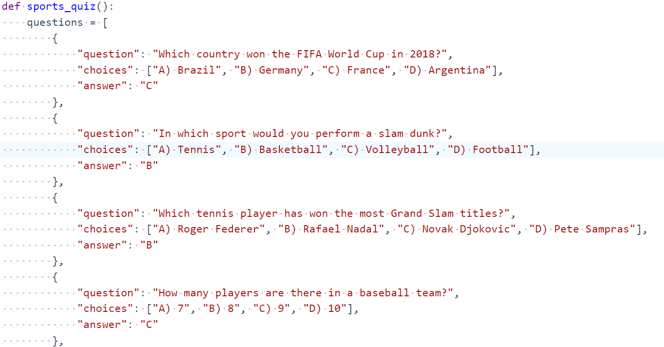

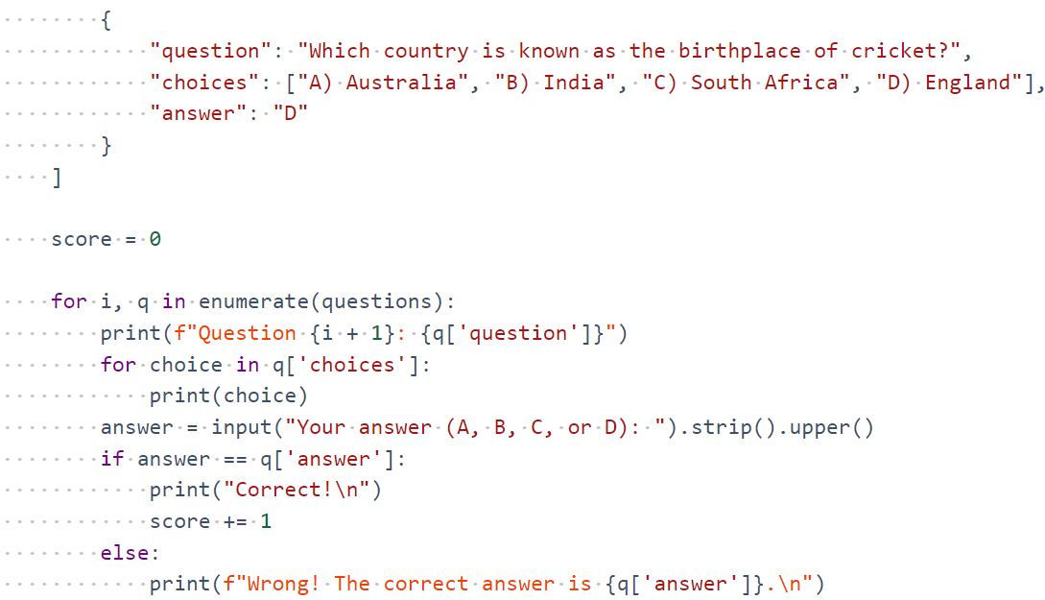

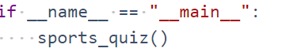

7.2 Output



7.3 Discussion

The Sports Quiz Generator successfully delivers an engaging and educational platform for sports enthusiasts, offering customizable quizzes based on user preferences and a comprehensive, regularly updated question database. The intuitive interface and immediate feedback enhance the user experience, while robust error management ensures reliability. Initial user feedback has been positive, highlighting the platform's ease of use and variety of questions. However, there are opportunities for improvement, such as incorporating machine learning for personalized quiz experiences, adding gamification elements, and expanding to a mobile application. These enhancements could further increase user engagement and retention, solidifying the application's value and appeal.

Chapter-8

Conclusion and Future Scope

Conclusion

The Sports Quiz Generator has achieved its goal of providing an engaging, customizable, and educational platform for sports enthusiasts. Through its user-friendly interface, extensive question database, and real-time updates, the application delivers a dynamic quiz experience that caters to a wide range of interests and knowledge levels. Effective error management and comprehensive logging ensure reliability and ease of maintenance, while initial user feedback has been overwhelmingly positive. The project successfully combines technical robustness with an enjoyable user experience, making it a valuable tool for both casual users and sports aficionados.

Future Scope
1.Machine Learning Integration:
- Implement adaptive learning algorithms to personalize quizzes based on user performance and preferences.
- Use predictive analytics to suggest quizzes and topics of interest, enhancing user engagement.
2.Enhanced Gamification:
- Introduce more gamification elements such as badges, achievements, and rewards to motivate users and increase retention.
- Develop competitive features like multiplayer quizzes and timed challenges to foster a sense of community and competition.
3.Multimedia Content:
- Incorporate multimedia elements such as images, videos, and audio clips into quiz questions to make them more interactive and engaging.
- Utilize augmented reality (AR) to create immersive quiz experiences, especially for mobile users.
5.Mobile Application Development:
- Develop native mobile applications for iOS and Android to provide a seamless experience for users on the go.
- Implement push notifications to remind users of new quizzes, updates, and achievements.
6.Expanded Question Database:
- Continuously update and expand the question database to include more niche sports categories and international sports events.
- Collaborate with sports experts and enthusiasts to curate high-quality, accurate trivia questions.
7.User Community and Social Features:
- Build a user community feature where users can create and share their own quizzes.
- Integrate social media sharing options to allow users to share their quiz results and challenge friends.
8.Data Analytics and Insights:
- Implement data analytics to track user engagement and performance metrics, providing insights for continuous improvement.
- Use analytics to identify popular quiz topics and trends, helping to tailor content to user interests.

Reference
1.Python Documentation:
- Official Python Documentation: https://docs.python.org/3/
- Django Documentation: https://docs.djangoproject.com/
- Flask Documentation: https://flask.palletsprojects.com/
2.Web Development and Frameworks:
- Django for Beginners by William S. Vincent: https://djangoforbeginners.com/
- Flask Web Development by Miguel Grinberg: https://flaskbook.com/
3.Database Management:
- SQLAlchemy Documentation: https://docs.sqlalchemy.org/
- MongoDB and PyMongo Documentation: https://pymongo.readthedocs.io/
4.Web Scraping:
- Beautiful Soup Documentation:
- https://www.crummy.com/software/BeautifulSoup/bs4/doc/
- Scrapy Documentation: https://docs.scrapy.org/en/latest/
5.Data Analysis:
- Pandas Documentation: https://pandas.pydata.org/docs/
- NumPy Documentation: https://numpy.org/doc/
6.Natural Language Processing:
- NLTK Book: http://www.nltk.org/book/
- SpaCy Documentation: https://spacy.io/usage
8.Error Handling and Logging:
- Python Logging Documentation: https://docs.python.org/3/library/logging.html
- Sentry for Python: https://docs.sentry.io/platforms/python/
9.Testing:
- PyTest Documentation: https://docs.pytest.org/en/stable/
- Selenium Documentation: https://www.selenium.dev/documentation/en/
10.Machine Learning and AI:
- Scikit-learn Documentation: https://scikit-learn.org/stable/documentation.html
- TensorFlow Documentation: https://www.tensorflow.org/overview
11.User Authentication and Security:
- Flask-Login Documentation: https://flask-login.readthedocs.io/en/latest/
- JWT (JSON Web Token) Documentation: https://jwt.io/introduction/
12.General Python Books and Tutorials:
- Python Crash Course by Eric Matthes: https://nostarch.com/pythoncrashcourse2e
- Automate the Boring Stuff with Python by Al Sweigart:
- https://automatetheboringstuff.com/

APPENDIX - A

def sports_quiz():
questions = [
{
"question": "Which country won the FIFA World Cup in 2018?",
"choices": ["A) Brazil", "B) Germany", "C) France", "D) Argentina"],
"answer": "C"
},
{
"question": "In which sport would you perform a slam dunk?",
"choices": ["A) Tennis", "B) Basketball", "C) Volleyball", "D) Football"],
"answer": "B"
},
{
"question": "Which tennis player has won the most Grand Slam titles?",
"choices": ["A) Roger Federer", "B) Rafael Nadal", "C) Novak Djokovic", "D) Pete Sampras"],
"answer": "B"
},
{
"question": "How many players are there in a baseball team?",
"choices": ["A) 7", "B) 8", "C) 9", "D) 10"],
"answer": "C"
},
{
"question": "Which country is known as the birthplace of cricket?",
"choices": ["A) Australia", "B) India", "C) South Africa", "D) England"],
"answer": "D"
}
]

score = 0

for i, q in enumerate(questions):
print(f"Question {i + 1}: {q['question']}")
for choice in q['choices']:
print(choice)
answer = input("Your answer (A, B, C, or D): ").strip().upper()
if answer == q['answer']:
print("Correct!\n")
score += 1
else:
print(f"Wrong! The correct answer is {q['answer']}.\n")

print(f"Your final score is {score} out of {len(questions)}")

if __name__ == "__main__":
sports_quiz()

